# **WEEK 2 PL SQL EXERCISES HANDS ON**

**SUBMITTED BY :-**

NAME – AYUSH SAHOO

SUPERSET ID – 6372243

COURSE – DIGITAL NURTURE 4.0 JAVA FSE

EMAIL – [ayush.sahoo003@gmail.com](mailto:ayush.sahoo003@gmail.com)

COLLEGE – C.V. RAMAN GLOBAL UNIVERSITY

**PRE – REQUISITE:-**

**STEP 1: CONNECT TO SQL (Here I have done the whole week 2 PL SQL questions in cmd prompt)**

**STEP 2: Enter password**

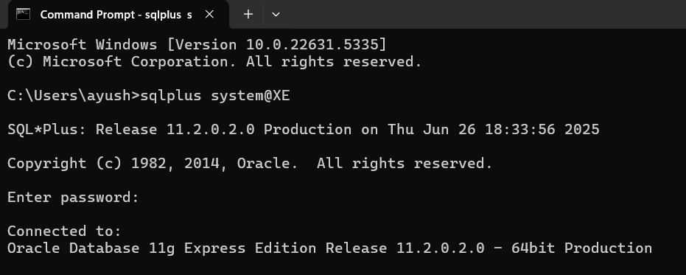

**Now for the required exercises:-**

**Exercise 1: Control Structures**

**Scenario 1: The bank wants to apply a discount to loan interest rates for customers above 60 years old.**

* + **Question: Write a PL/SQL block that loops through all customers, checks their age, and if they are above 60, apply a 1% discount to their current loan interest rates.**

**Scenario 2: A customer can be promoted to VIP status based on their balance.**

* + **Question: Write a PL/SQL block that iterates through all customers and sets a flag IsVIP to TRUE for those with a balance over $10,000.**

**Scenario 3: The bank wants to send reminders to customers whose loans are due within the next 30 days.**

* + **Question: Write a PL/SQL block that fetches all loans due in the next 30 days and prints a reminder message for each customer.**

**QUERY:-**

**SCENARIO 1:-**

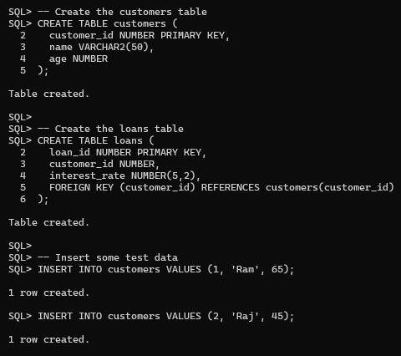

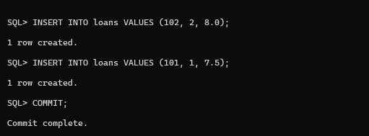

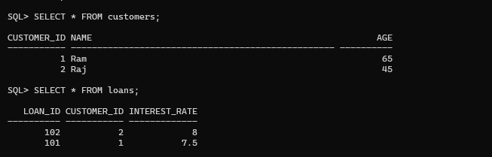

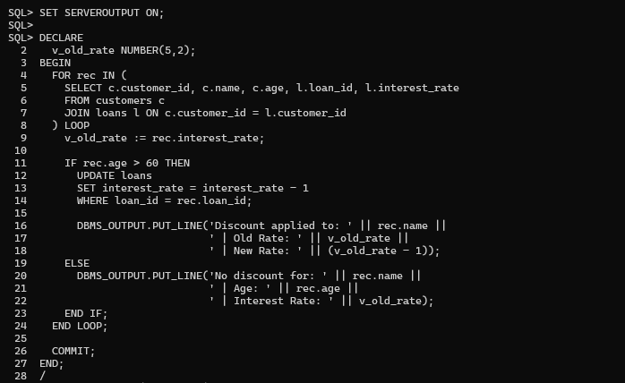

**OUTPUT:-**



**QUERY (FOR DISCOUNTED APPLY):-**



**OUTPUT:-**



**For Scenario 2 we have to first DROP the TABLE customers and loans then we will execute another one like this :**

**SCENARIO 2:-**

**Drop the table:**

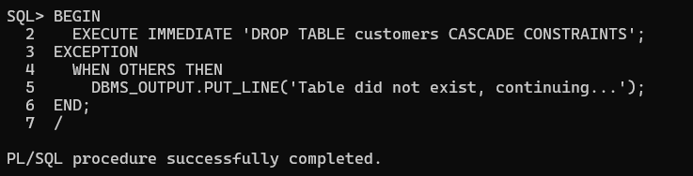

**Create another one**

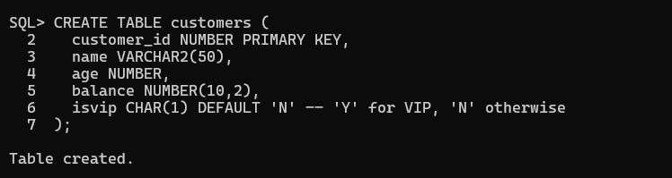

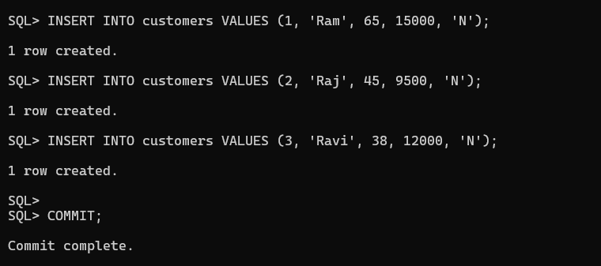

**Main Query:-**

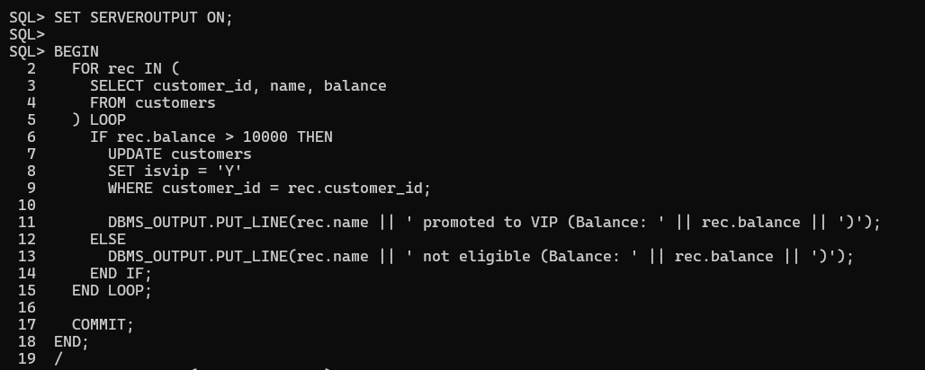

**Output:-**



**Query to get table as output:-**



**Output :-**

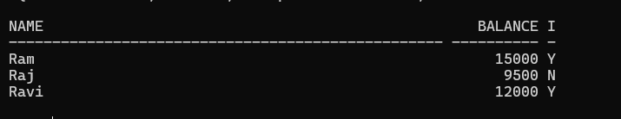

**Now for scenario 3:-**

**Now again before doing anything drop the table and then create it with appropriate data :-**

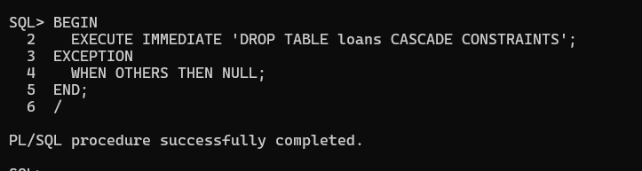

**Table Creation:-**

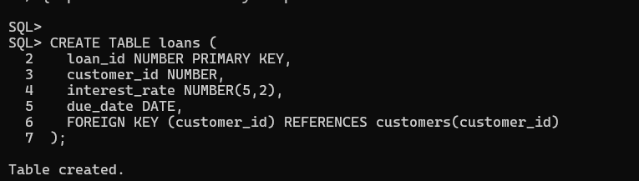

**Insertion Data:-**

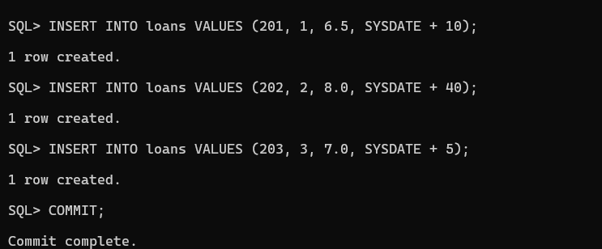

**Main Query:-**

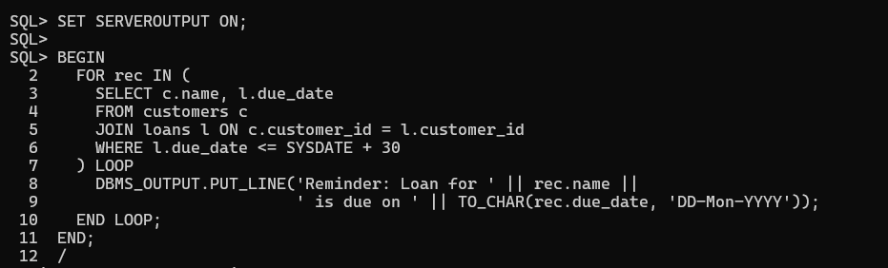

**Output:-**



**Another Query for displaying the Table:-**

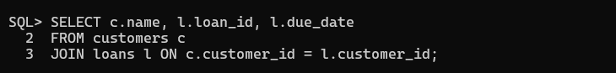

**Output:-**



**Exercise 3: Stored Procedures**

**Scenario 1: The bank needs to process monthly interest for all savings accounts.**

* + **Question: Write a stored procedure ProcessMonthlyInterest that calculates and updates the balance of all savings accounts by applying an interest rate of 1% to the current balance.**

**Scenario 2: The bank wants to implement a bonus scheme for employees based on their performance.**

* + **Question: Write a stored procedure UpdateEmployeeBonus that updates the salary of employees in a given department by adding a bonus percentage passed as a parameter.**

**Scenario 3: Customers should be able to transfer funds between their accounts.**

* + **Question: Write a stored procedure TransferFunds that transfers a specified amount from one account to another, checking that the source account has sufficient balance before making the transfer.**

**SOLUTION:-**

**Scenario 1:**

**Step 1: Delete all the tables (if existed)**

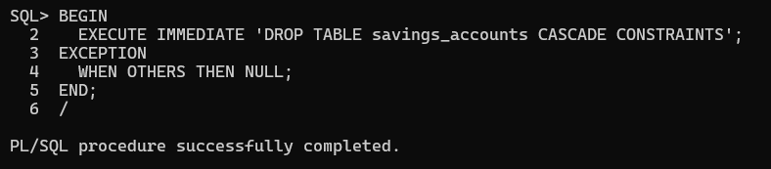

**Step 2: Create a Table and insert Data :**

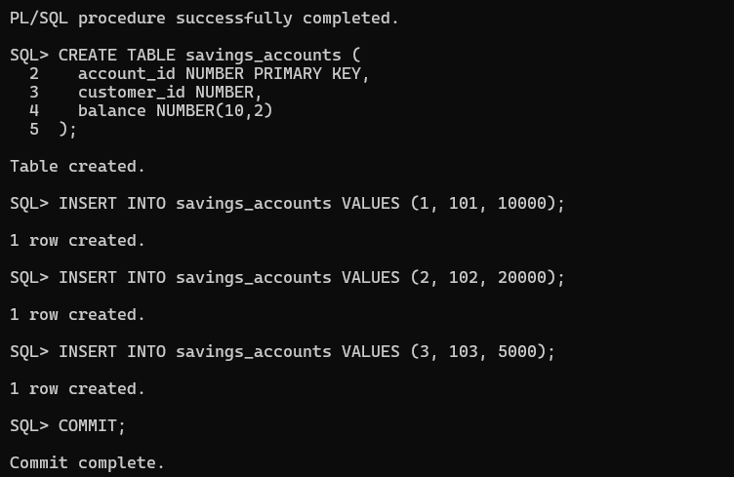

**Step 3: Main Query**

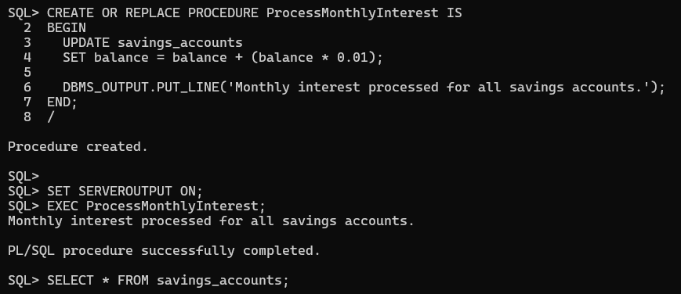

**OUTPUT:**

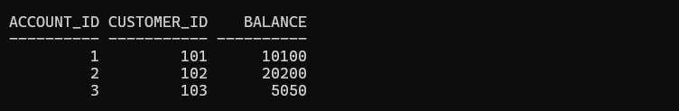

**Scenario 2:**

**Step 1: Delete all the tables (if existed):**

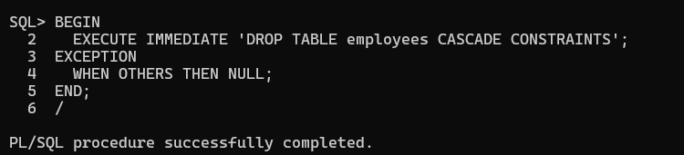

**Step 2: Create a Table and insert Data :**

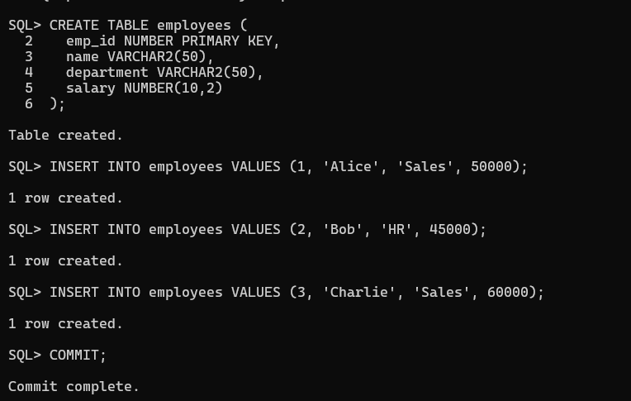

**Step 3: Main Query:**

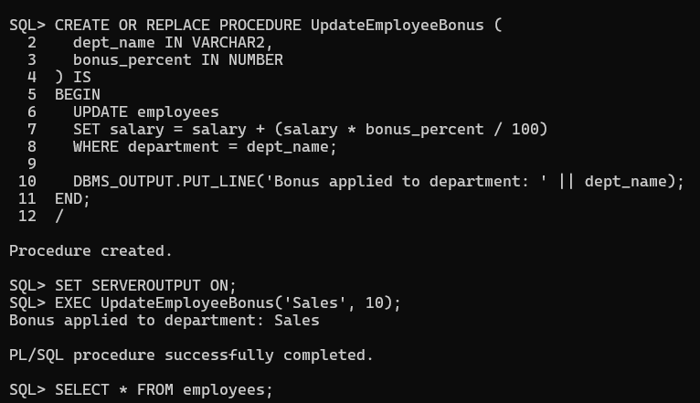

**OUTPUT:**

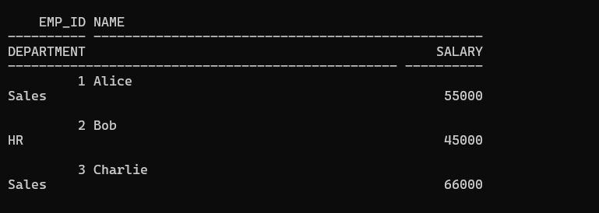

**Scenario 3:**

**Step 1: Delete all the tables (if existed)**

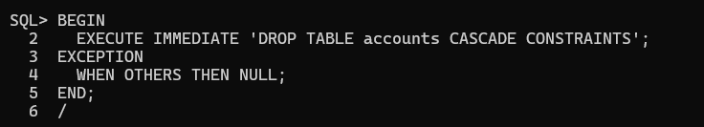

**Step 2: Create a Table and insert Data :**

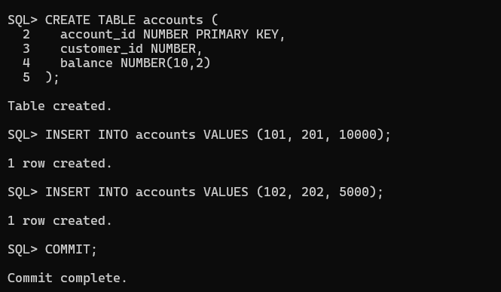

**Step 3: Main Query**

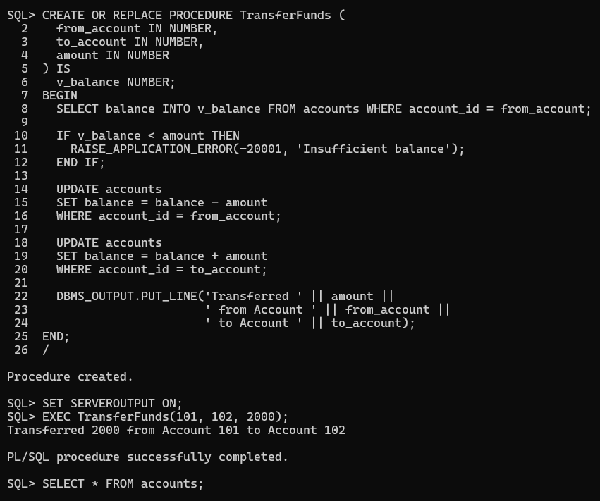

**OUTPUT:**

